SCOPE STATEMENT

Project Name: Spectrum Sensing and Signal Identification Using USRP
Date: October 10th, 2016

Business Purpose: Introduce a significant improvement to the Army’s radio frequency situational awareness by developing the capability for signal identification and modulation classification across a specified spectrum.

Project Goals:
- Time: Complete the project by 30 April, 2016
- Cost: $400 + sponsor supplied equipments
- Quality: Identify clean signals with 100% accuracy for agreed upon modulation schemes (for the case where environmental noise is not a factor).
- Use open source software and COTS h (Commercial off-the-shelf) hardware.
- Easy to Read interface - able to be interpreted by a first time user.
- Multi-purpose hardware (Laptop and SDR only).
- Do not interfere with any FCC regulations.

Project Work Statement: Create website, create a Tx device with one radio, complete GNU radio tutorials, isolate signals, identify analog modulation, identify digital modulation, combine modulation identifications, make operation real-time

Key Deliverables:
Fall midterm report, Fall final report, Spring midterm report, Spring final report, development computer, website, basic tx device for testing, basic rx device (raw spectrum) device, working prototype

Key Milestones:
Fall midterm report by Oct 18th
Fall final report by Dec 15th
Spring reports TBD
Development computer by Oct 30th
Website by Nov 1st
Basic Tx device for testing by Dec 1st
Basic Rx (raw spectrum) device by Dec 30th
Prototype by February 1st

Major Constraints:
The group is limited to hardware of the sponsor’s choosing (which should be sufficient, but is not up to the group to decide).

Major Assumptions:
The group is assuming that MITRE is acting on behalf of the military, another key stakeholder.
The group is assuming that hardware provided by MITRE is attainable by the military and can be used if the project goal was to be met.

Exclusions:
The use of machine learning to complete the overall goal is not guaranteed and is one of many methods of achieving the project goals.

“I Pledge my Honor that I have abided by the Stevens Honor System.”

Andrew Guthrie Joseph Pang Kunal Patel

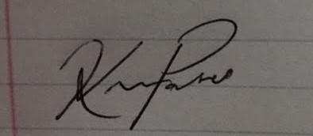
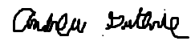

Thomas Wright Vijayrahul Raja
